Exercise 3: Assertions in JUnit
Scenario: You need to use different assertions in JUnit to validate your test results.
Implementation:

AssertionTest.java
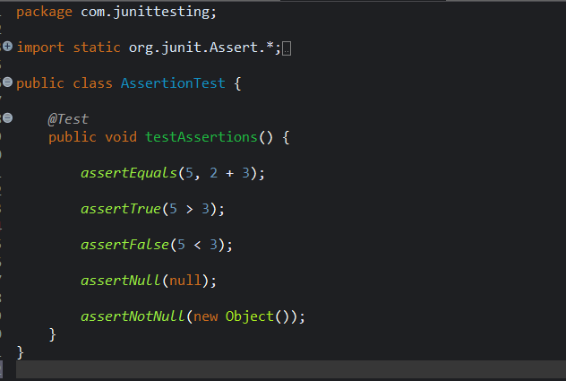

OUTPUT:

